Untitled Card Game Song Moodboards & Inspo

City Theme

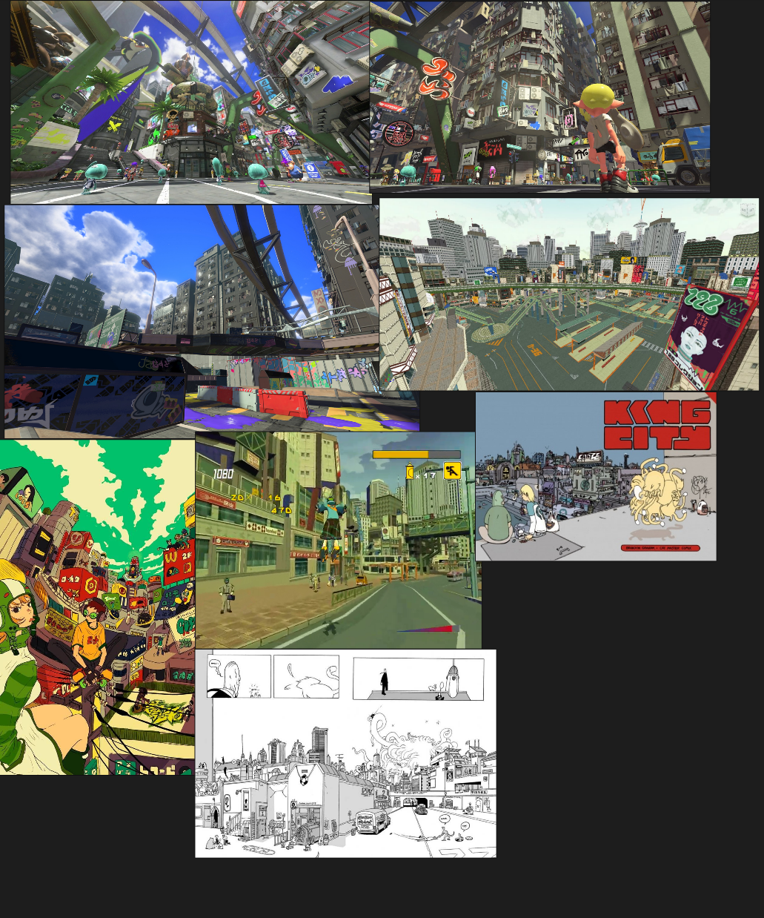
Relatively relaxed but with a bit of funk, should be relatively long and loop seamless since the player will spend the majority of their time in this area

Shop Theme

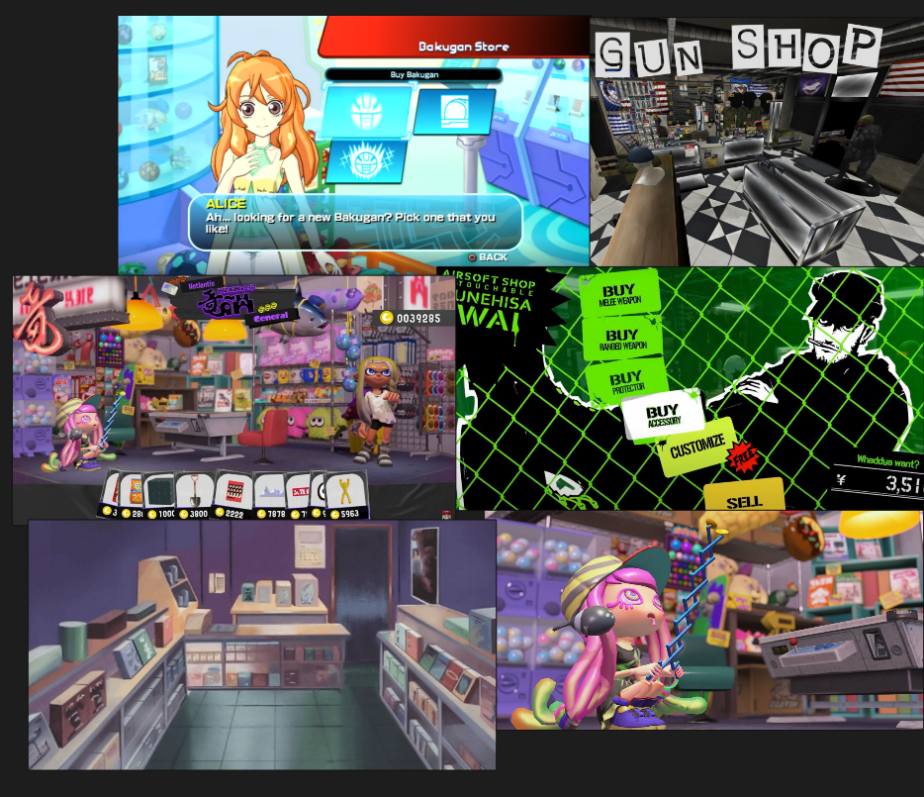
Relatively upbeat, but with an undercurrent of thinking / curiosity. The player is excited to buy stuff but has to budget, so they’re thinking about possibilities

Pack Opening Theme
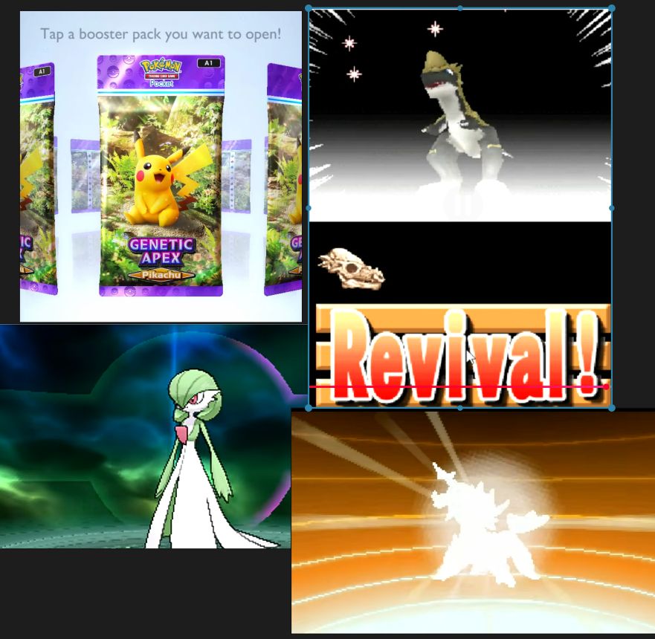
Hype and excitement! This one will be trickier, it would be cool to have a buildup to the pack opening, a big stinger, then a loop after. Maybe a special stinger for when a rare card is revealed too

